|  |  |
| --- | --- |
|  | ISE Assignment #03    BY TO  Hamzah Ahmed [4164-FBAS/BSSE/F21] Sir. Shakir Khattak 12/5/22 |

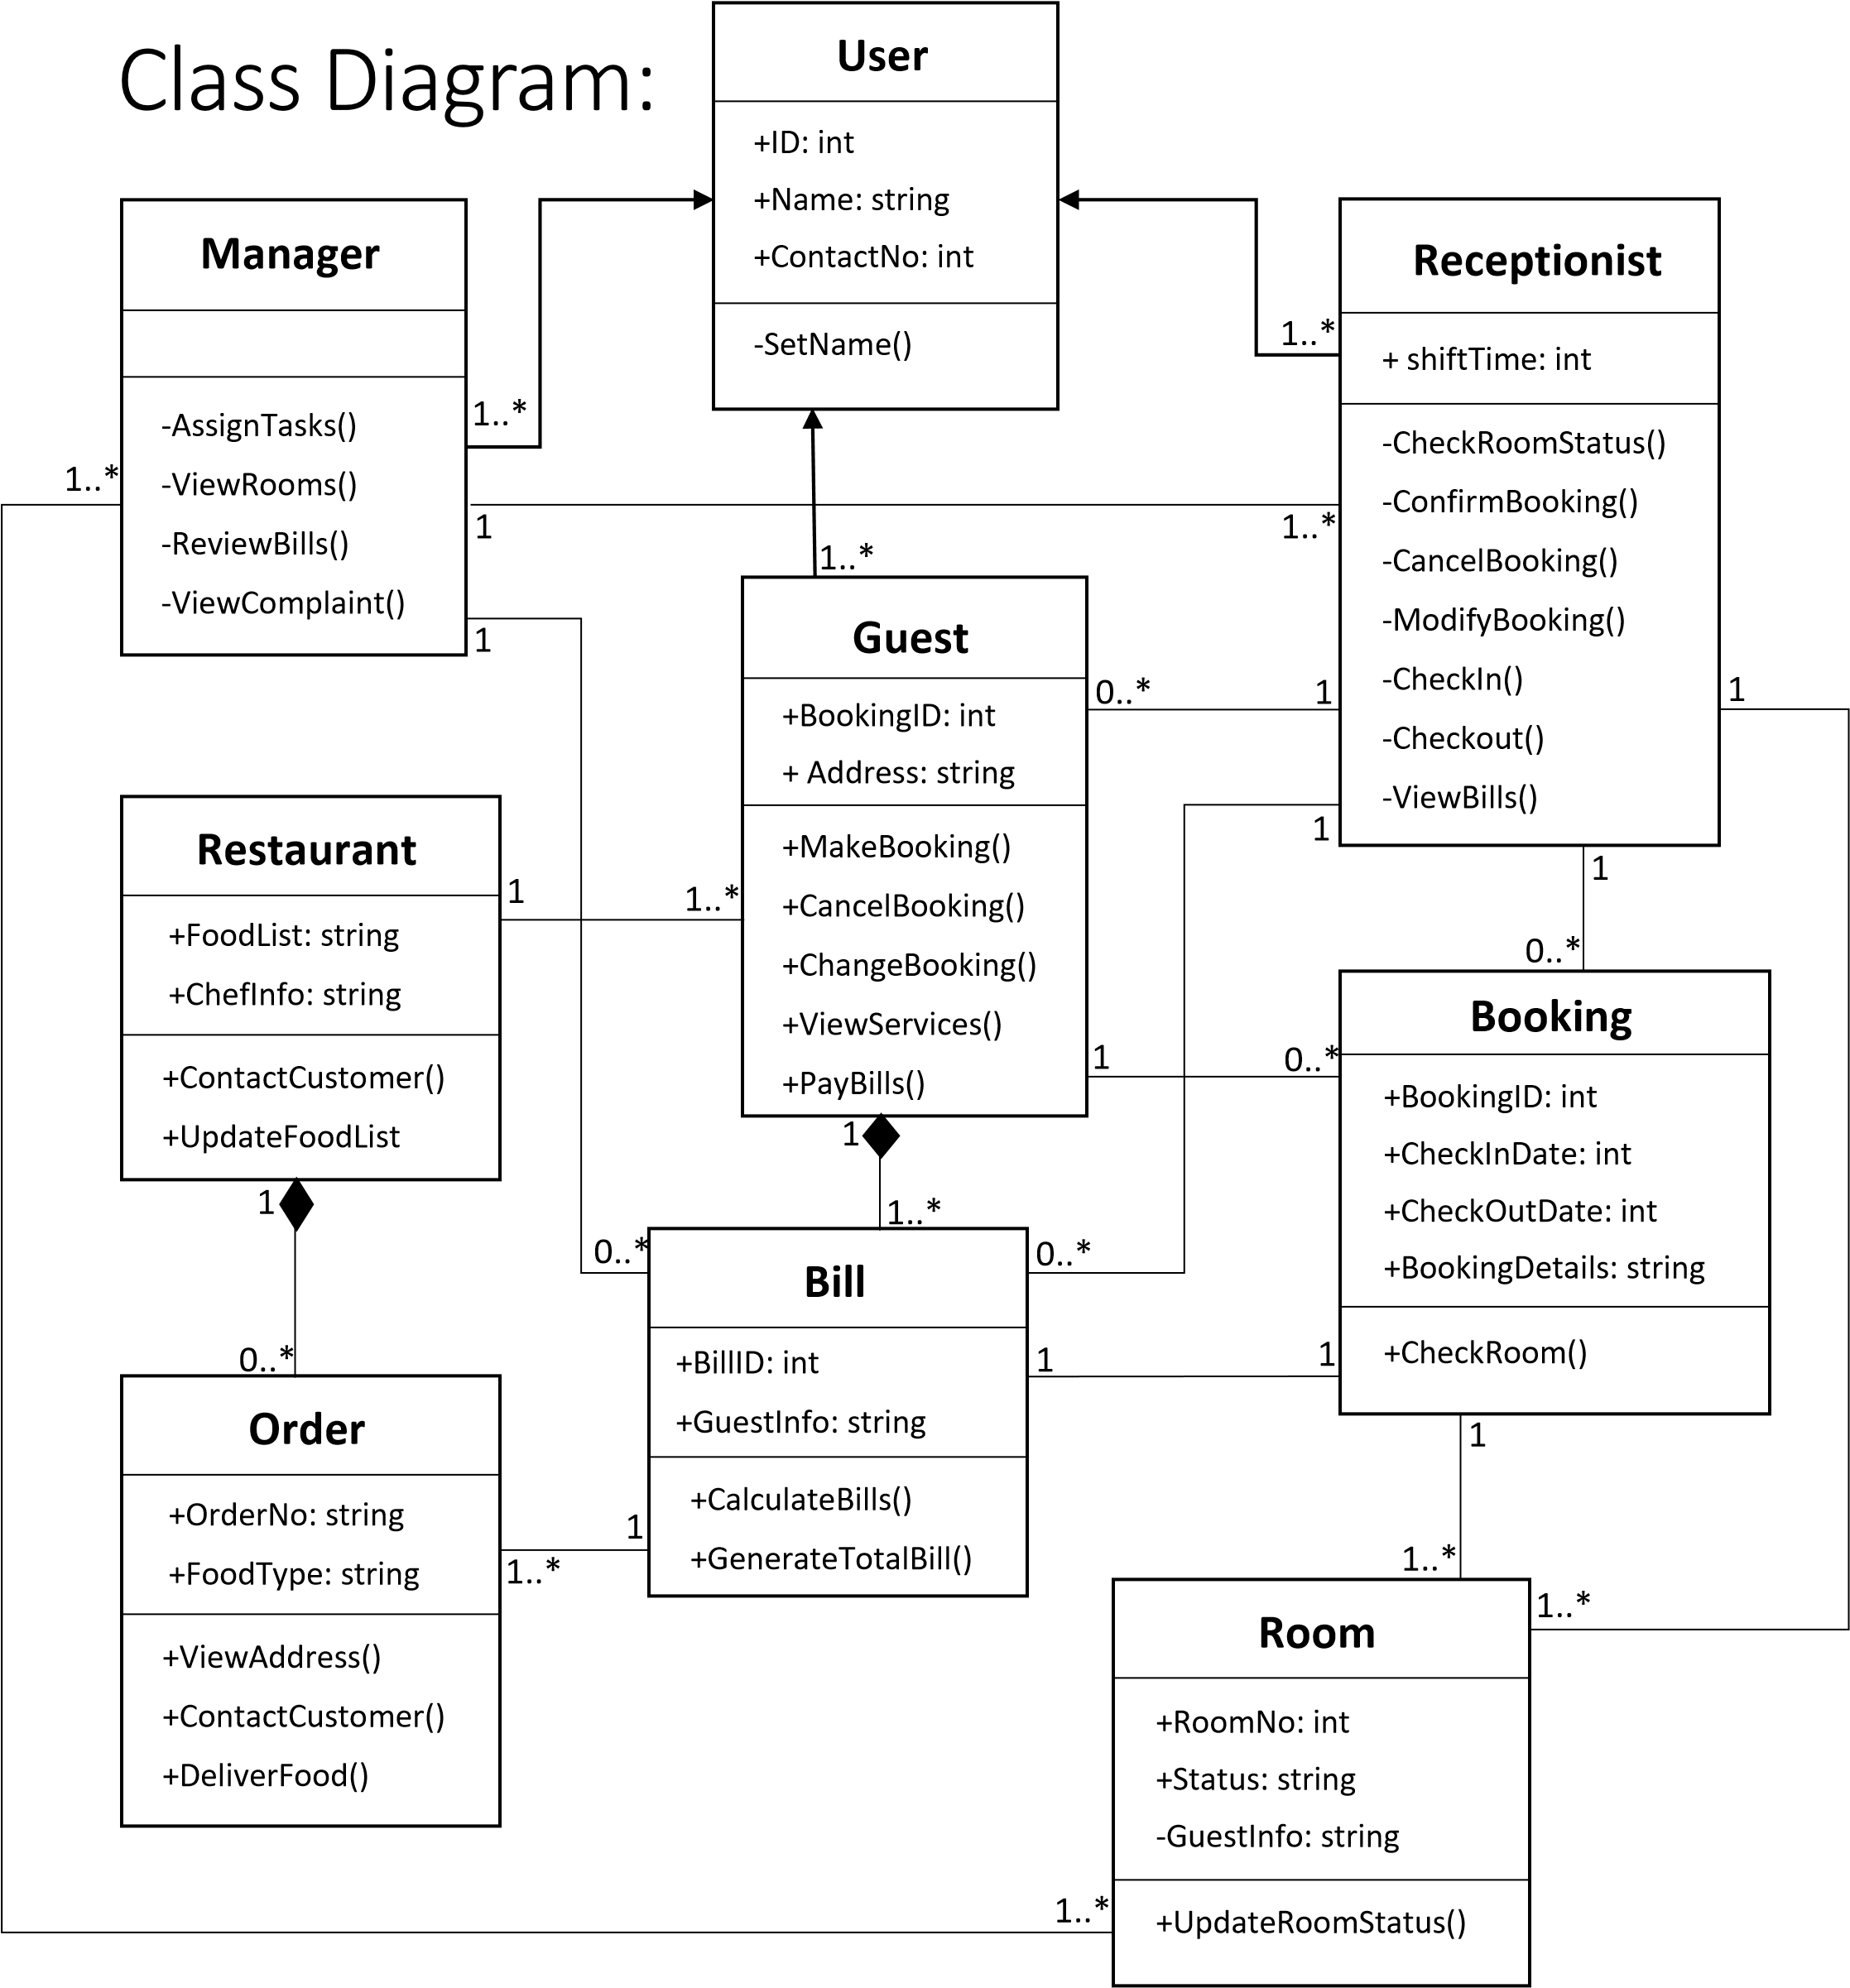

Sequence Diagram:

